Date: 2024-03-14

Module: Cart Popup

Function: Checking your products

**Explanation:**

Cart Popup is the small box that displays after clicking the cart button, it displays the products that are in your cart. It is one of the multiple functions that the header has  
  
The Cart Popup has some general information that is both obvious why it has and some extra functions to help out with sales.

The design of the Cart Popup is pretty simple; it is not needed to look complicated with its design as its only function is to display the products before going over to the purchasing page. Another design feature is that the quantity of cart amount will be display ahead of time before pressing the button.

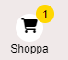

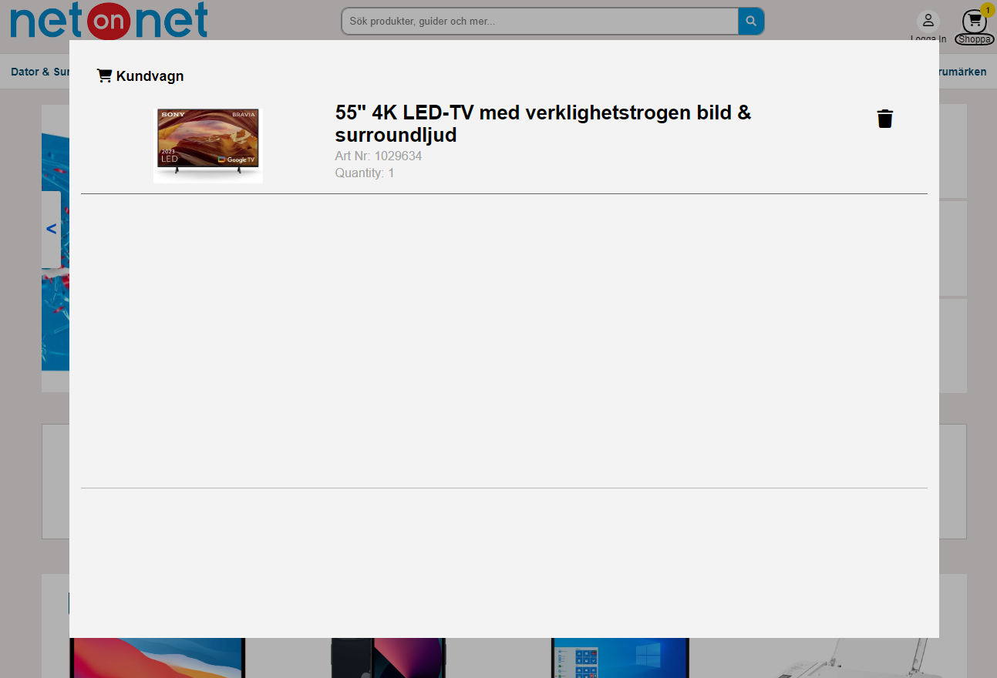

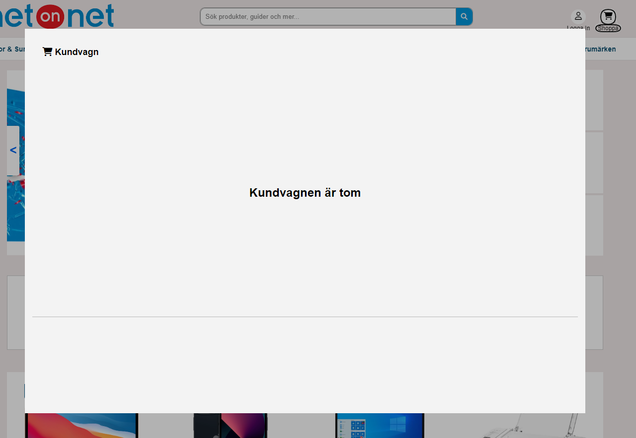

The real purpose for Cart Popup is to confirm your purchase by looking into what product(s) you have selected before going to the payment. On this menu you have the option to increase or decrease the quantity of a product whilst also removing products in the cart. The product displays simple information like name, article number, quantity and a picture of it within the cart.